Mini pupper

Forward & inverse kinematics and jacobian

# computation of Forward kinematics using Denavit–Hartenberg parameters

## Fixed leg Reference coordinate frame #0

* Right-hand coordinate system
* Centred on coxa revolute joint
* X upward
* Y leftward
* Z backward

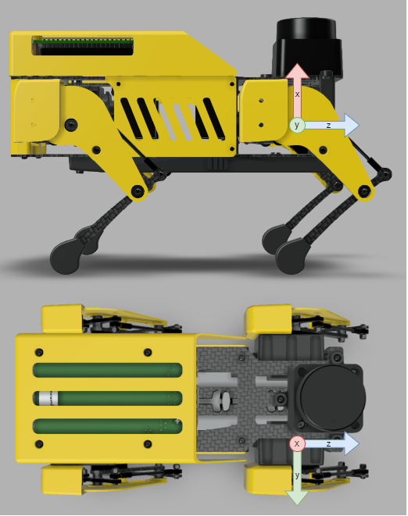

## DH Parameters

* is rotation about previous Z axis, from old X to new X
* **d** is offset along previous Z axis
* **a** is offset along new X axis
* **α** is rotation about new X, from old Z to new Z

|  |  |  |  |  |
| --- | --- | --- | --- | --- |
| Links |  | d | a | α |
| 1 |  | 0 |  | -90° |
| 2 |  | (Left Legs)  (Right Legs) |  | 0 |
| 3 |  | 0 |  | 0 |

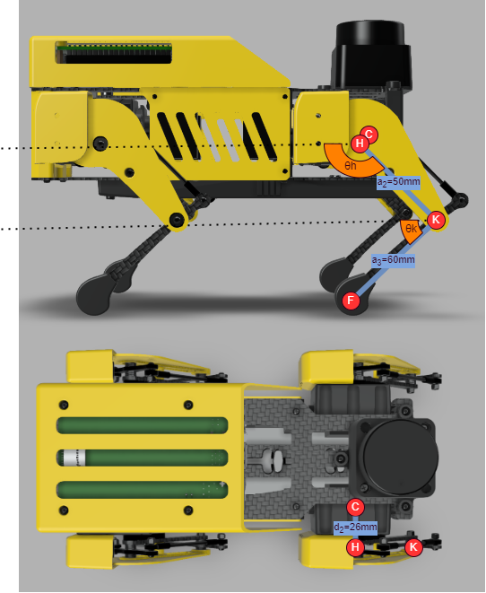

|  |  |  |
| --- | --- | --- |
| Variables | Description | Values |
|  | Distance from coxa revolute joint to hips revolute joint along X1 | 26 mm |
|  | Distance from hips revolute joint to knee revolute joint along X2 | 50 mm |
|  | Distance from knee revolute joint to foot along X3 | 60 mm |
|  | Coxa revolute joint angle, from X0 axis to X1 axis | *controlled by servo #1* |
|  | Hips revolute joint angle, from body HORIZONTAL to FEMUR (X2) | *controlled by servo #2* |
|  | Knee revolute joint angle, from body HORIZONTAL to TIBIA (X3) | *controlled by servo #3* |

## Transformation matrices using DH parameters

Coordinate frame of link , noted , is located at the end of the link, aligned with new X and Z axis, after all rotations and translations.

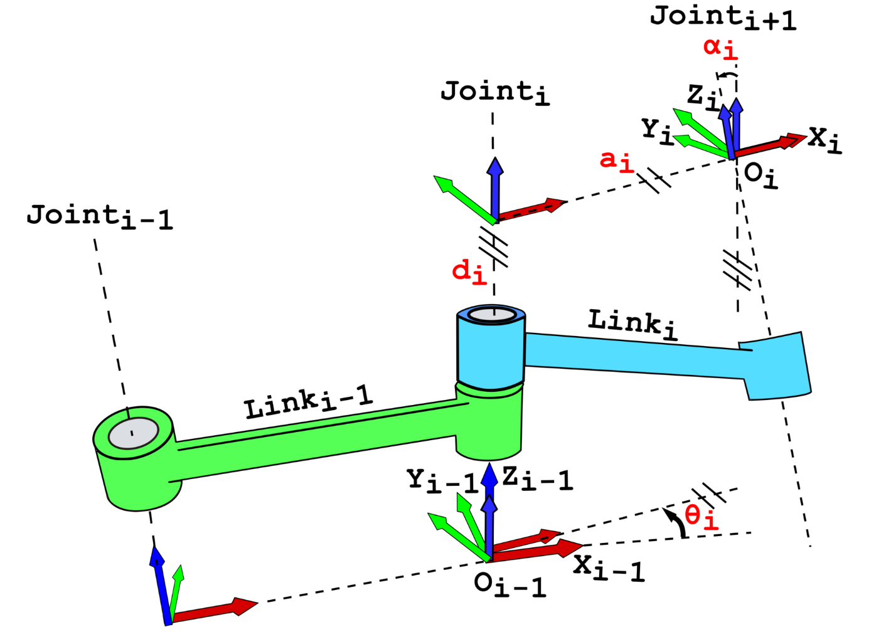

### (reminder) DH transformation matrix

Transformation from coordinate frame j to coordinate frame j-1:

### COXA (j=1)

where

|  |  |
| --- | --- |
|  |  |
|  |  |

### Femur (j=2)

* For left legs:
* For right legs:

where

|  |  |
| --- | --- |
|  |  |
|  |  |

### TIBIA (j=3)

where

|  |  |
| --- | --- |
|  |  |
|  |  |

### « end-effector » Transformation matrix to leg reference frame #0

* For left legs:
* For right legs:

where

|  |  |  |
| --- | --- | --- |
|  |  |  |
|  |  |  |

## Transformation matrices using modified DH parameters

Coordinate frame of link , noted , is located the beginning of the link, aligned with previous Z axis and new X axis, after rotation and translation .

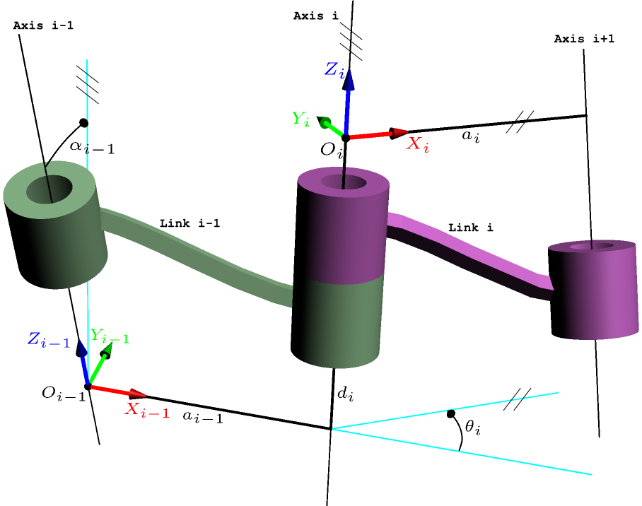

### (reminder) modified DH transformation matrix

Transformation from coordinate frame j to coordinate frame j-1:

### COXA (j=1)

where

|  |  |
| --- | --- |
|  |  |
|  |  |

### Femur (j=2)

* For left legs:
* For right legs:

where

|  |  |
| --- | --- |
|  |  |
|  |  |

### TIBIA (j=3)

where

|  |  |
| --- | --- |
|  |  |
|  |  |

### FOOT (j=4)

### « end-effector » Transformation matrix to leg reference frame #0

* For left legs:
* For right legs:

where

|  |  |  |
| --- | --- | --- |
|  |  |  |
|  |  |  |

Note: both methods (DH and Modified DH) give the same result.

## Forward Kinematic

Position of foot in leg reference frame #0 is given by the 3x1 submatrix of describing translation:

* For left legs:
* For right legs:

# computation of jacobian

Velocity of the foot in leg reference frame #0 is given by the Jacobian  :

where

## Partial Differentiation Method

* For left legs:
* For right legs:

## Velocity propagation method

### Velocity propagation (Theory)

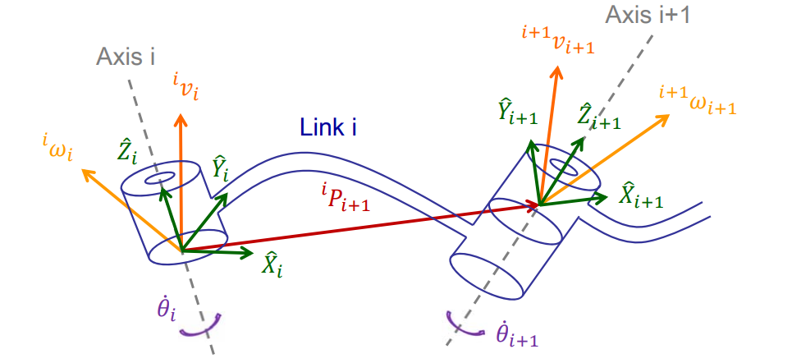

### COXA (i=1)

then

### HIPS (i=2)

where

then

### KNEE (i=3)

where

then

### tibia/FOOT (i=4)

where

then

### Jacobian in last frame

Extracting vector:

then

### Jacobian in base frame

where

then

Note: both methods (partial differentiation and velocity propagation) give the same result.

# computation of ground reaction force

Ground reaction force in leg reference frame #0 is given by the inverse transposed Jacobian and the torque of each joint:

where

## Singularities

Numerical approach may be used for singularities computation

## INVERSE maTRIX (if NON-ZERO determinant)

Numerical approach may be used for inverse Jacobian matrix computation

# Inverse KINEMATIC

Geometric approach.